**INSTALLATION MANUAL**

**I.** **System Requirements** 2

**II.** **Installation** 2

Python Installation 2

A. Database Management System (DBMS) Installation. 5

B. SignAPROS Download 11

C. Database creation 13

D. SignAPROS Installation 16

# **System Requirements**

* A 64-bit processor, at least Core i3.
* At least 8GB of RAM. More than 16GB is highly recommended.
* At least 100GB of free disk space on an NTFS-formatted hard drive. FAT32 will not work, as some of the Git pack files are larger than 4GB.
* Windows 10 or newer.

# **Installation**

## Python Installation

Python 3.9 is advised but greater versions work too. To install it, follow the next steps.

1. Go to <https://www.python.org/downloads/> and download the latest version for Windows by clicking on the yellow button.

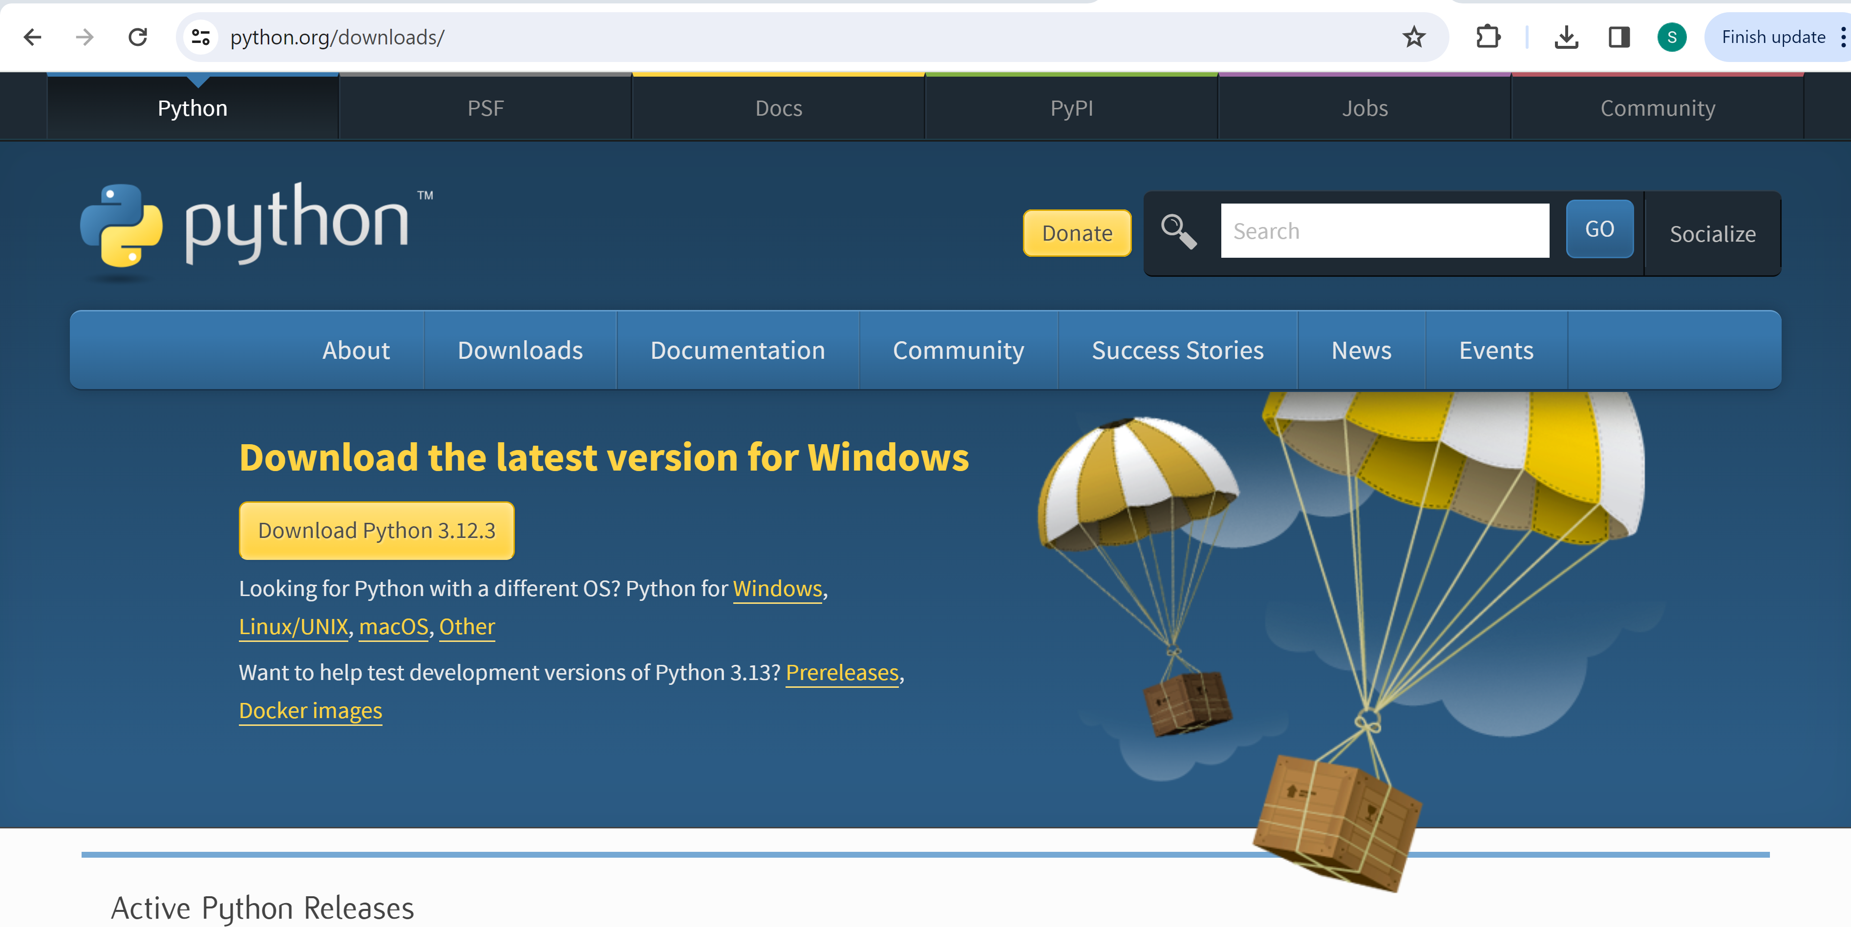

File will be downloaded

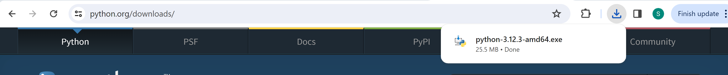

1. Go to the “Downloads” folder and execute the downloaded file, in this case “python-3.12.3-amd64.exe”, by double-clicking on it. The following window will be displayed.

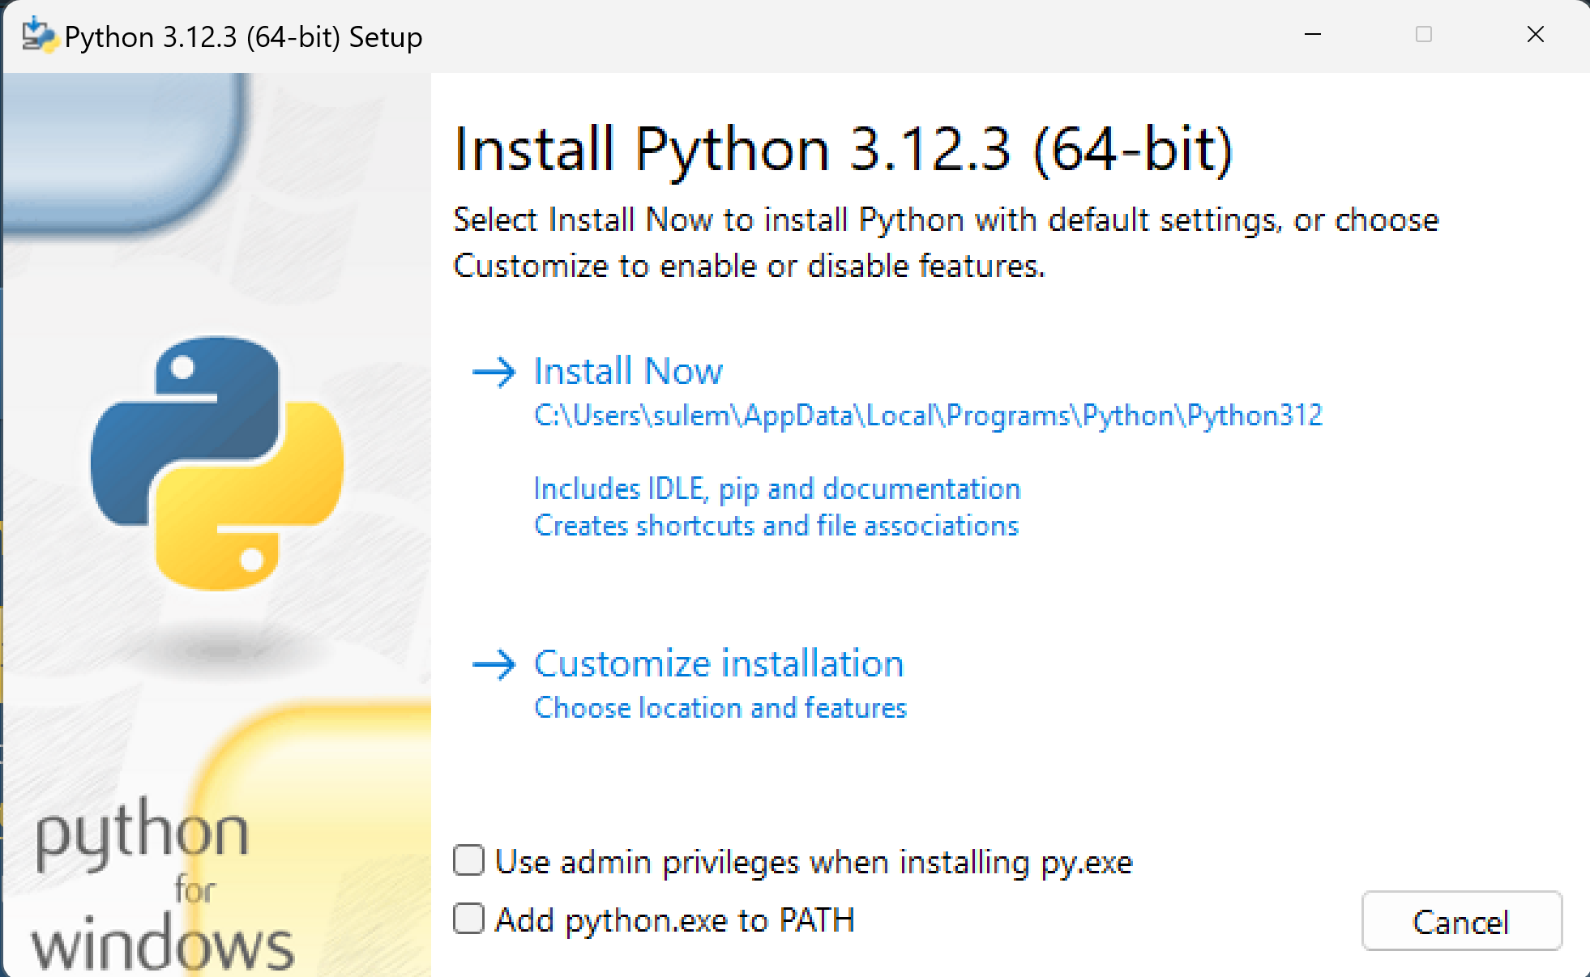

1. First, select the two options that appear at the bottom of the window. After, click over “Install Now” to continue..

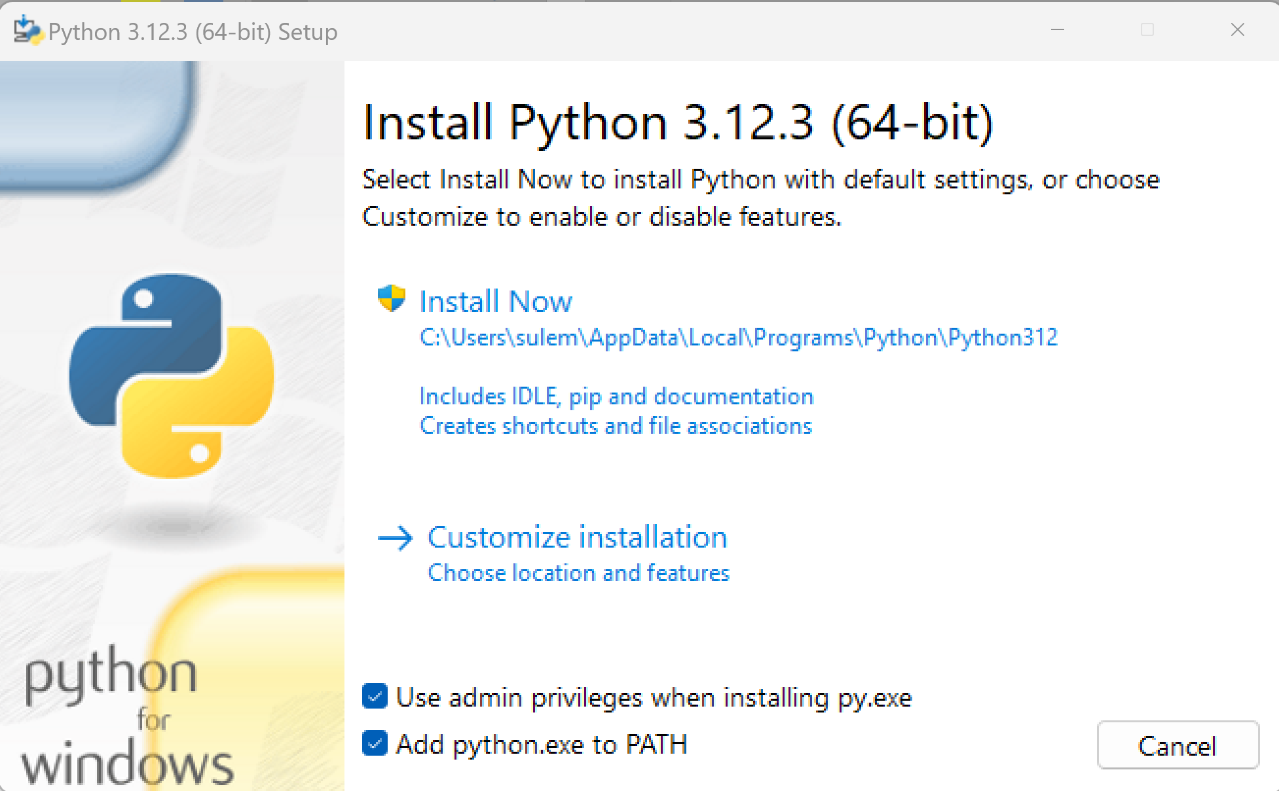

**2**

**1**

1. The system will ask you “Do you want to allow this app to make changes to your device?”. Please click on the “Yes” button to continue.
2. Please wait until the installation ends, and close the window by clicking on the “Close” button.

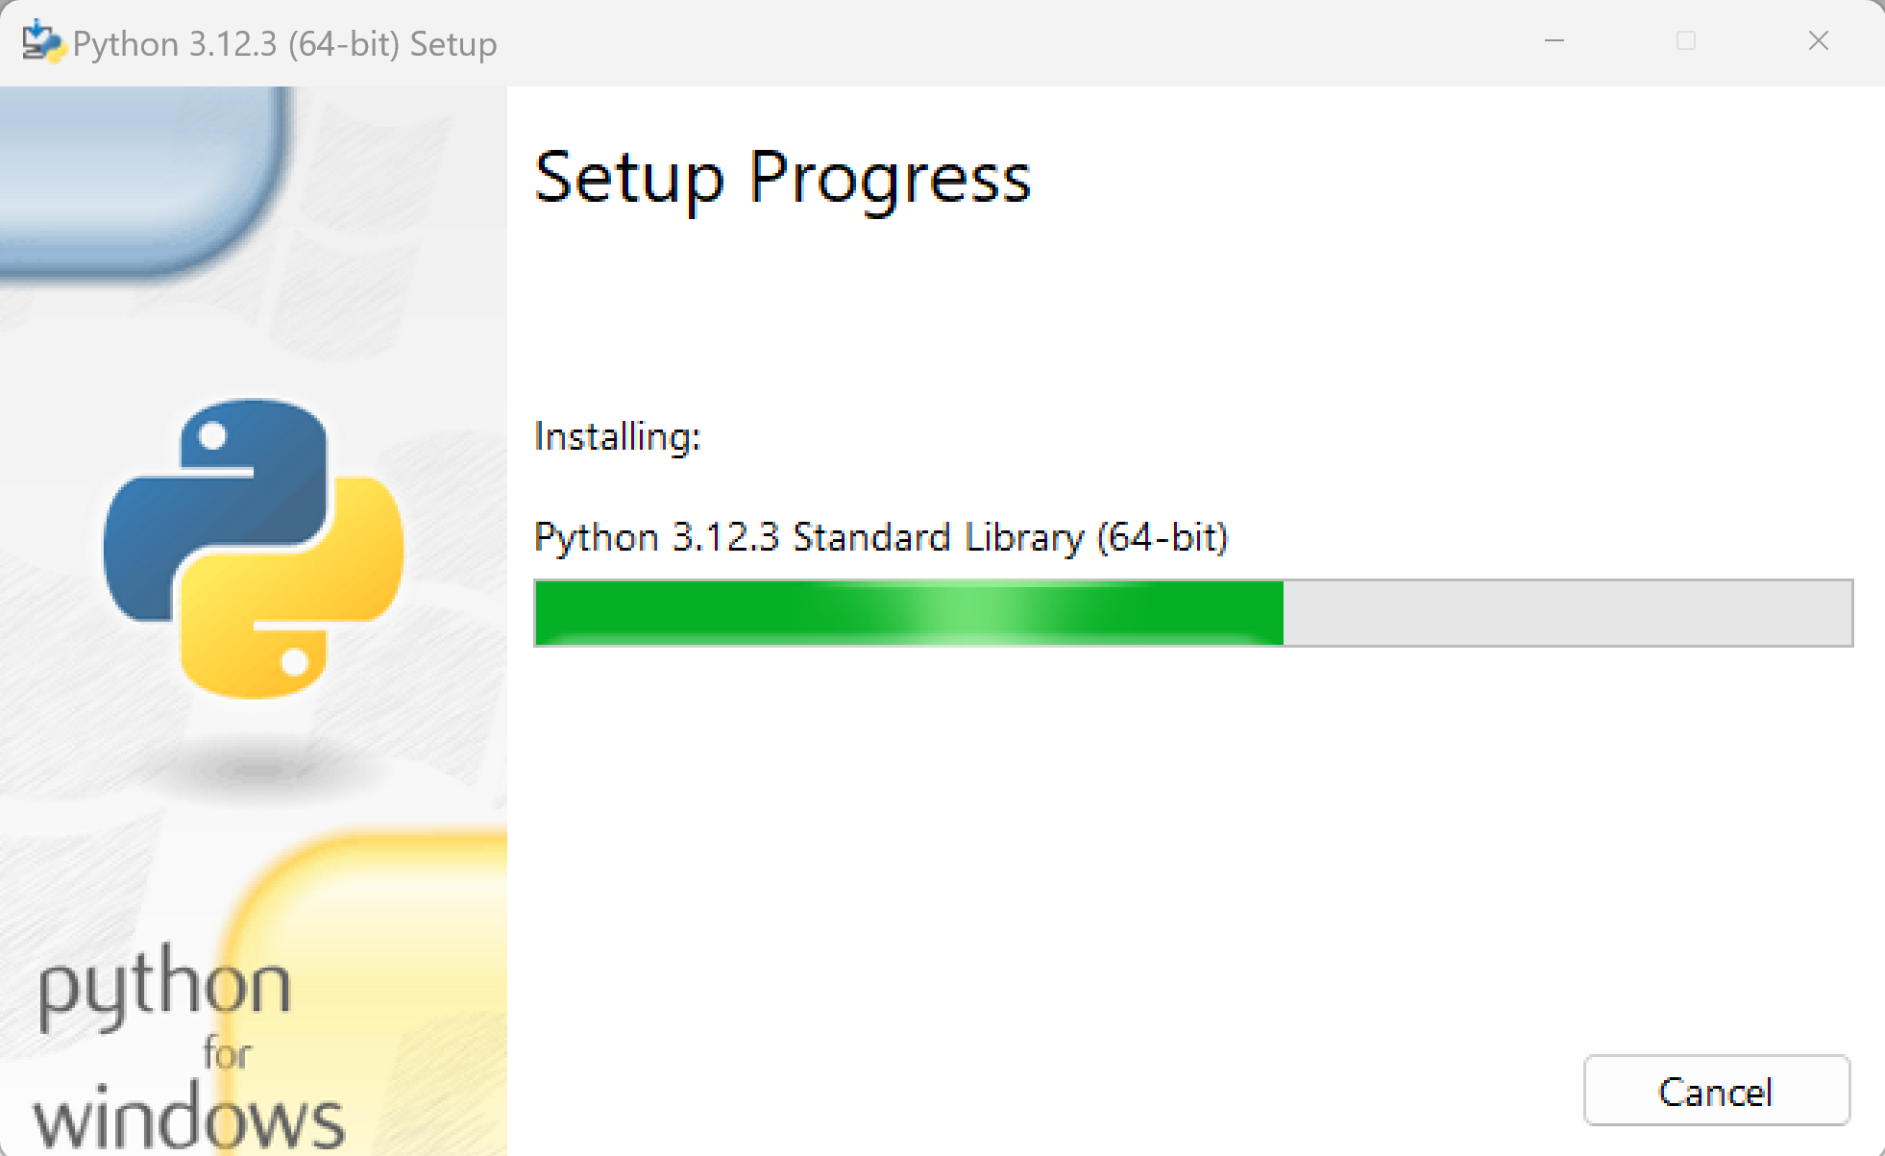

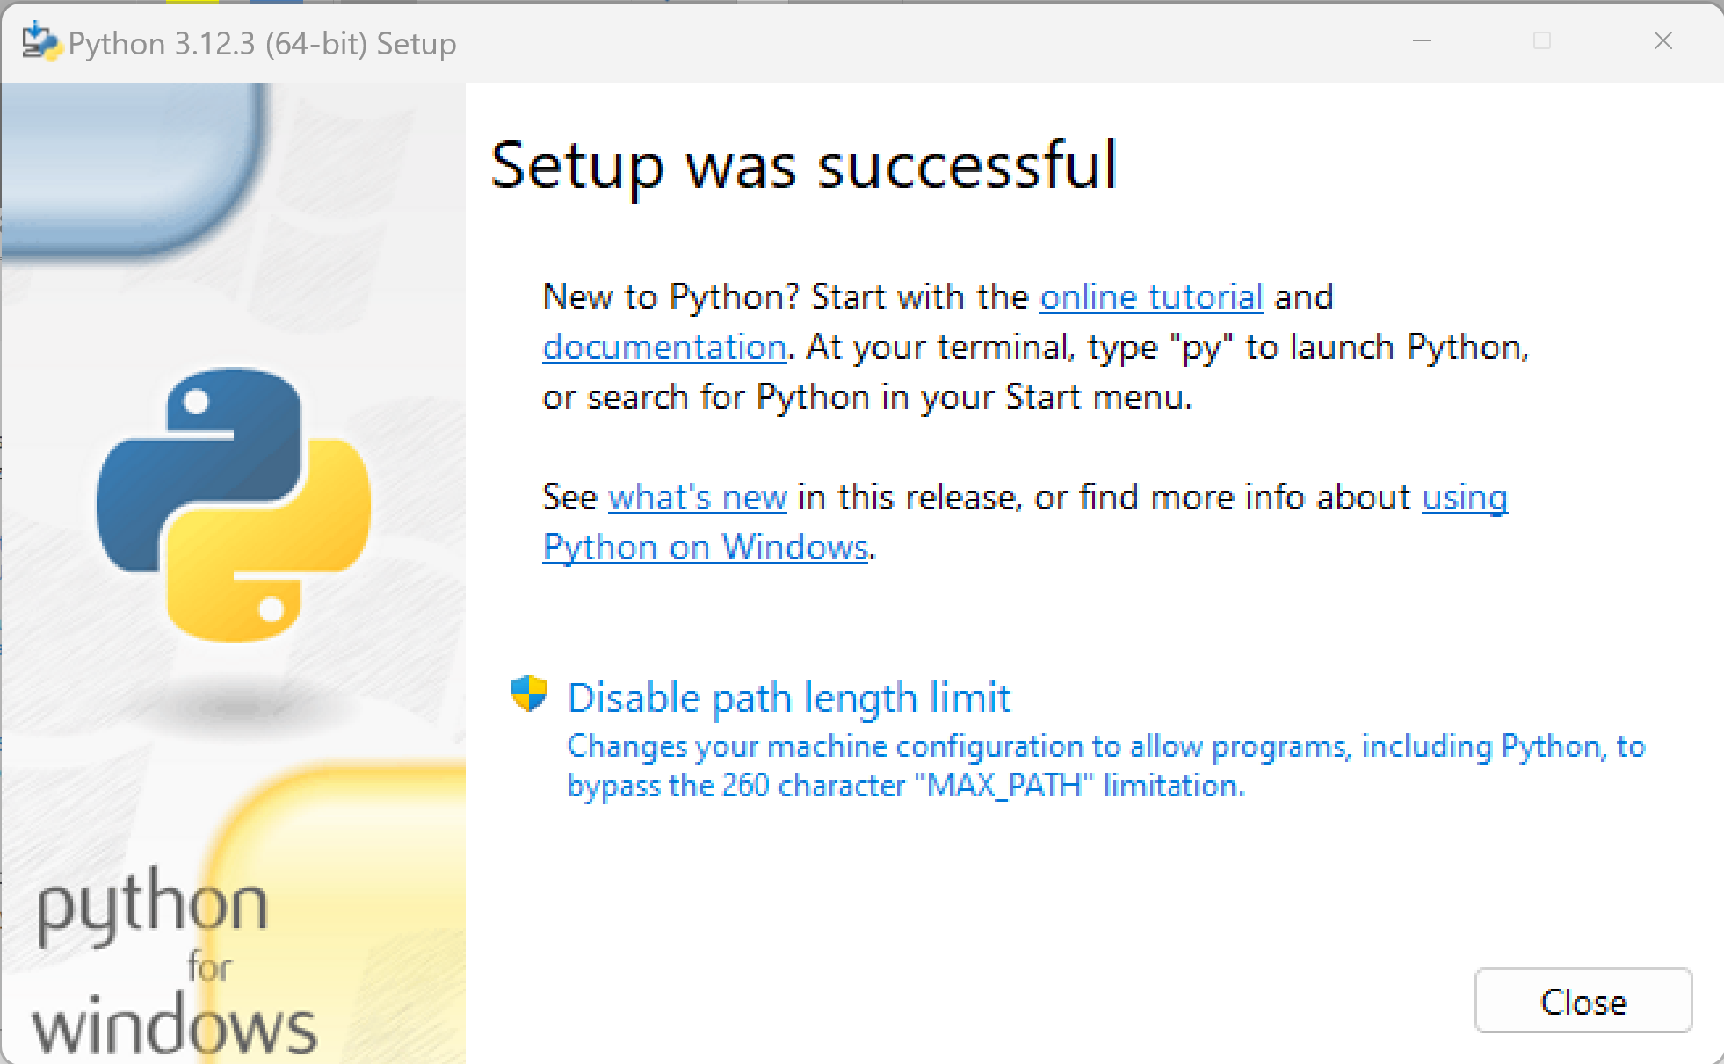

## Database Management System (DBMS) Installation.

Database Management System Installation is needed to use the GGG System.

1. Enter the Postgresql DBMS download manager at:

<https://www.enterprisedb.com/downloads/postgres-postgresql-downloads>

1. Download the 14.11 version for Windows x86-64 as shown in the next figure.

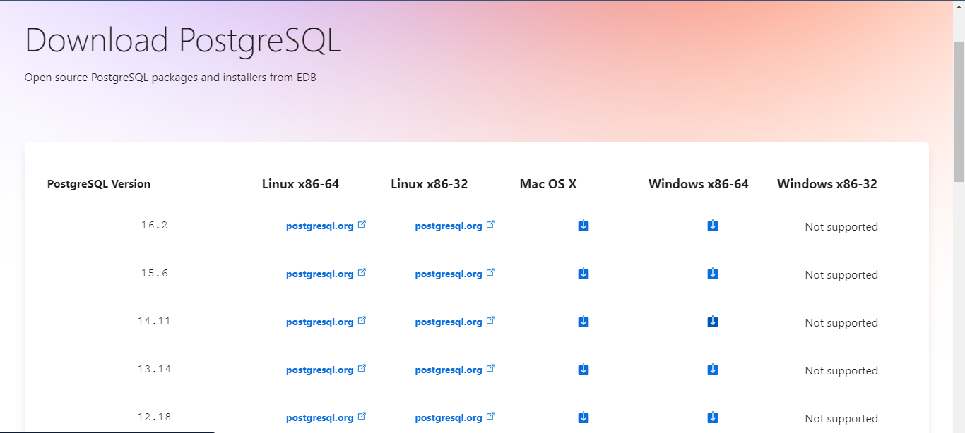

1. Go to the “Downloads” folder and execute the file “postgresql-14.11-1-windows-x64.exe” by double-clicking on it. The system will show you a message asking “Do you want to allow this app to make changes to your device?”, please click on the “YES” button.
2. After that, a window will be displayed and you should click on the “Next” button (see the following figure).

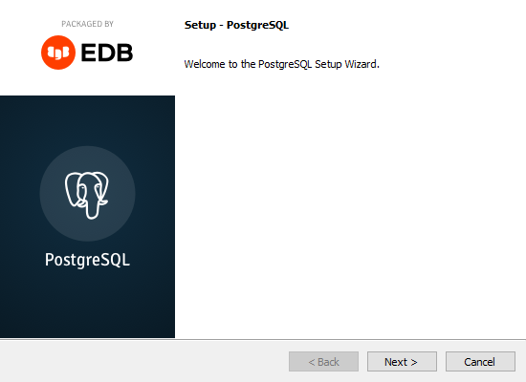

1. On the following screen you can specify the location where you want PostgreSQL to be installed (the default path is recommended). Once the path is set, click on the “Next” button.

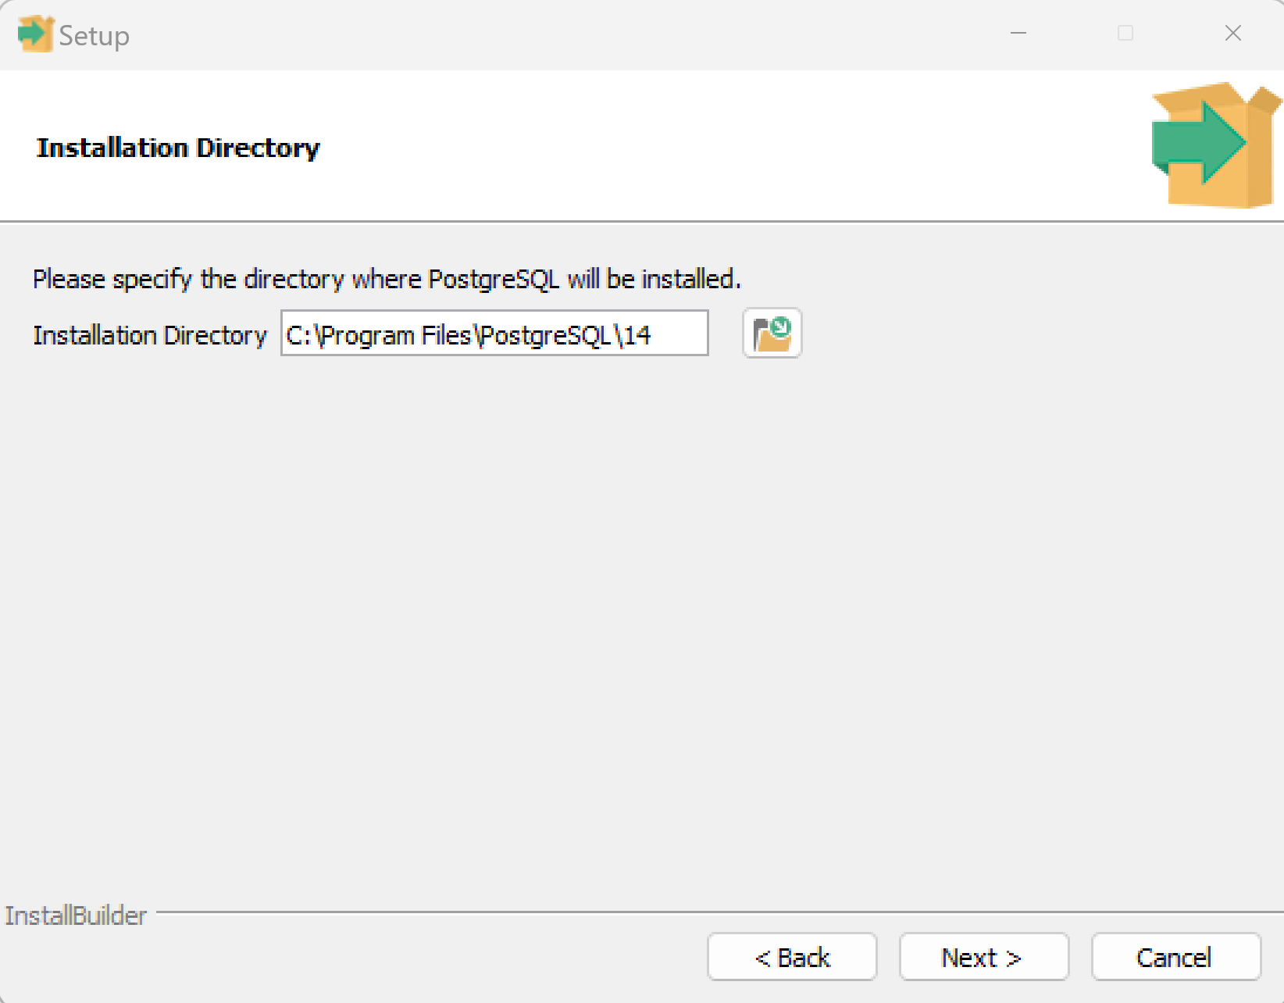

1. After that, you need to select the “PostgreSQL Server”, “pgAdmin 4” and “Command Line Tools” as shown in the following figure, and click on the “Next” button.

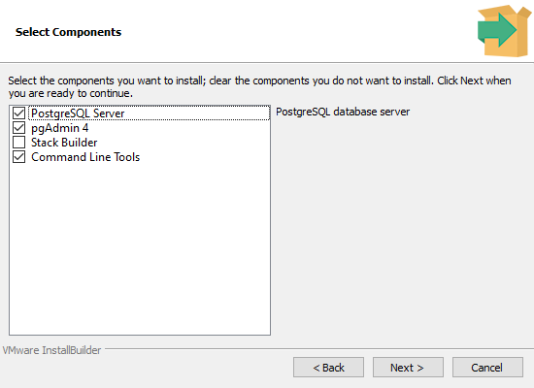

1. Select the path where you want to save the DB information and click on the “Next” button. A default path is recommended.

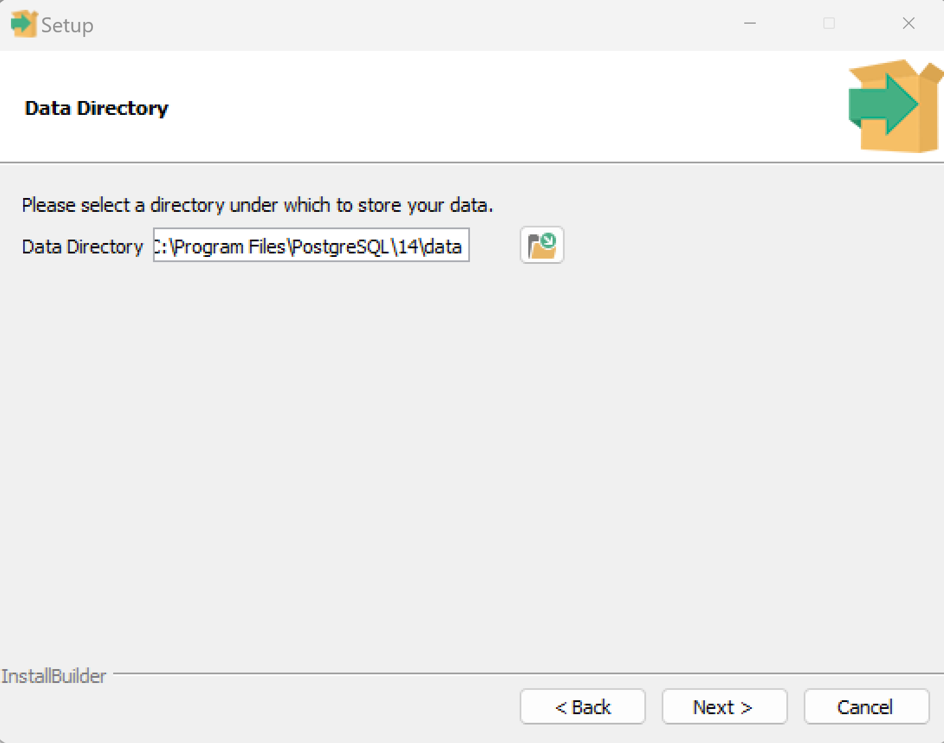

1. Provide a password to get access to the database and click on the “Next” button. Don't forget to save the password for further use.

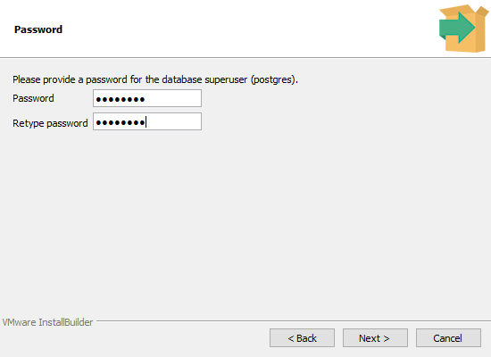

1. On the next screen, you can set the port for the database connection; please set “5432” as your port as follows.

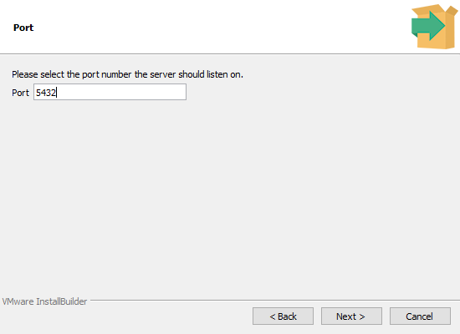

1. Select “[Default locale]” as the geographical location to be used by the database server, and click on the “Next” button (as shown in the following figure).

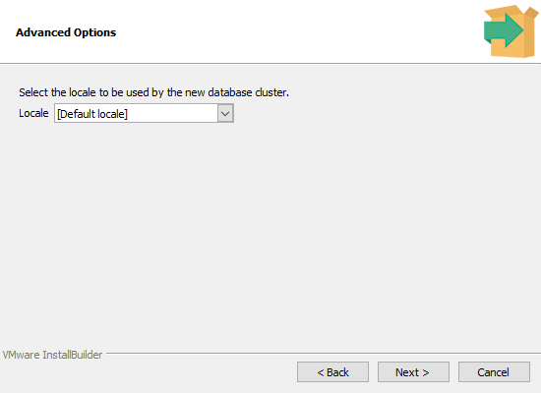

1. Click “Next” to validate the installation details.

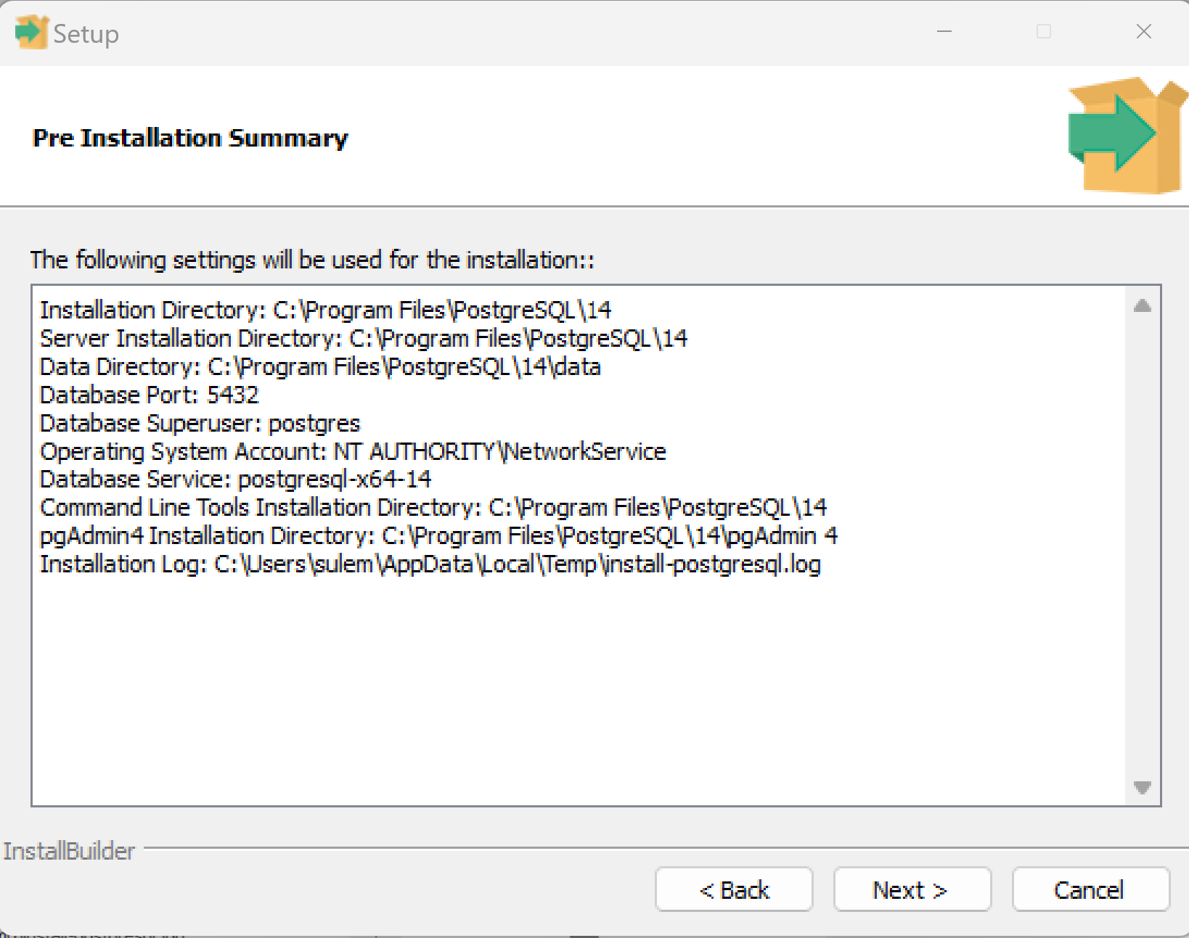

1. Click “Next” once more to start the installation:

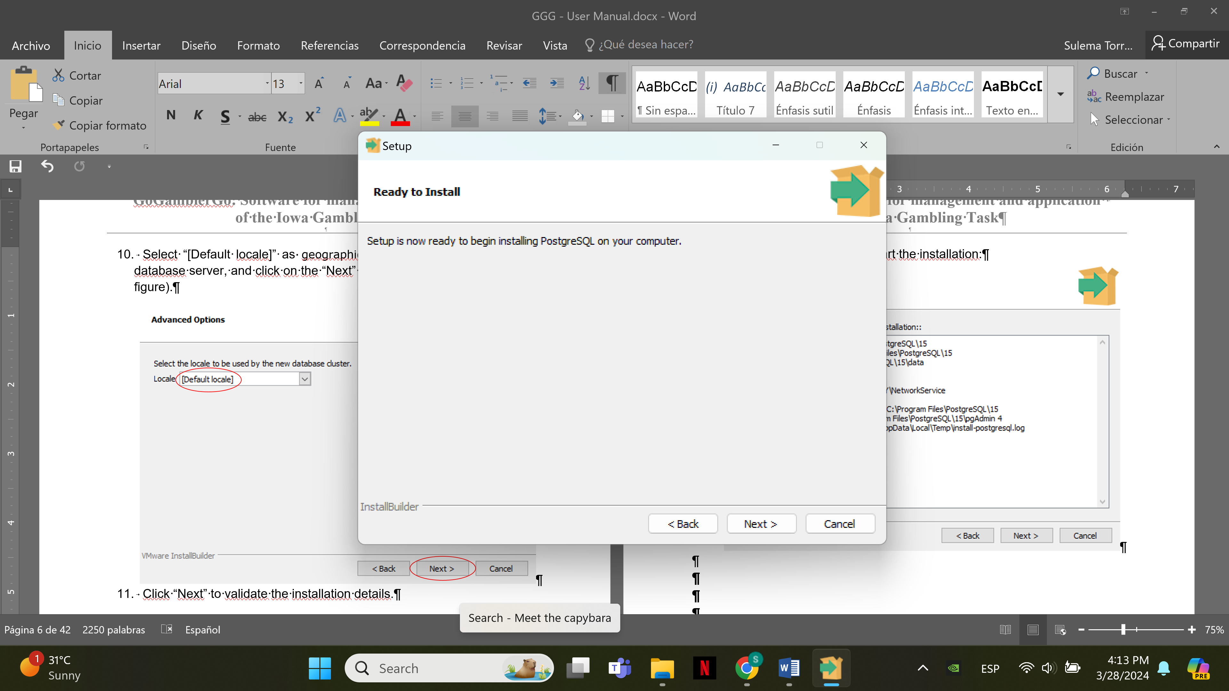

1. A window will appear showing that the program is being installed. Please wait until the program finishes the installation and show the window of the next step.

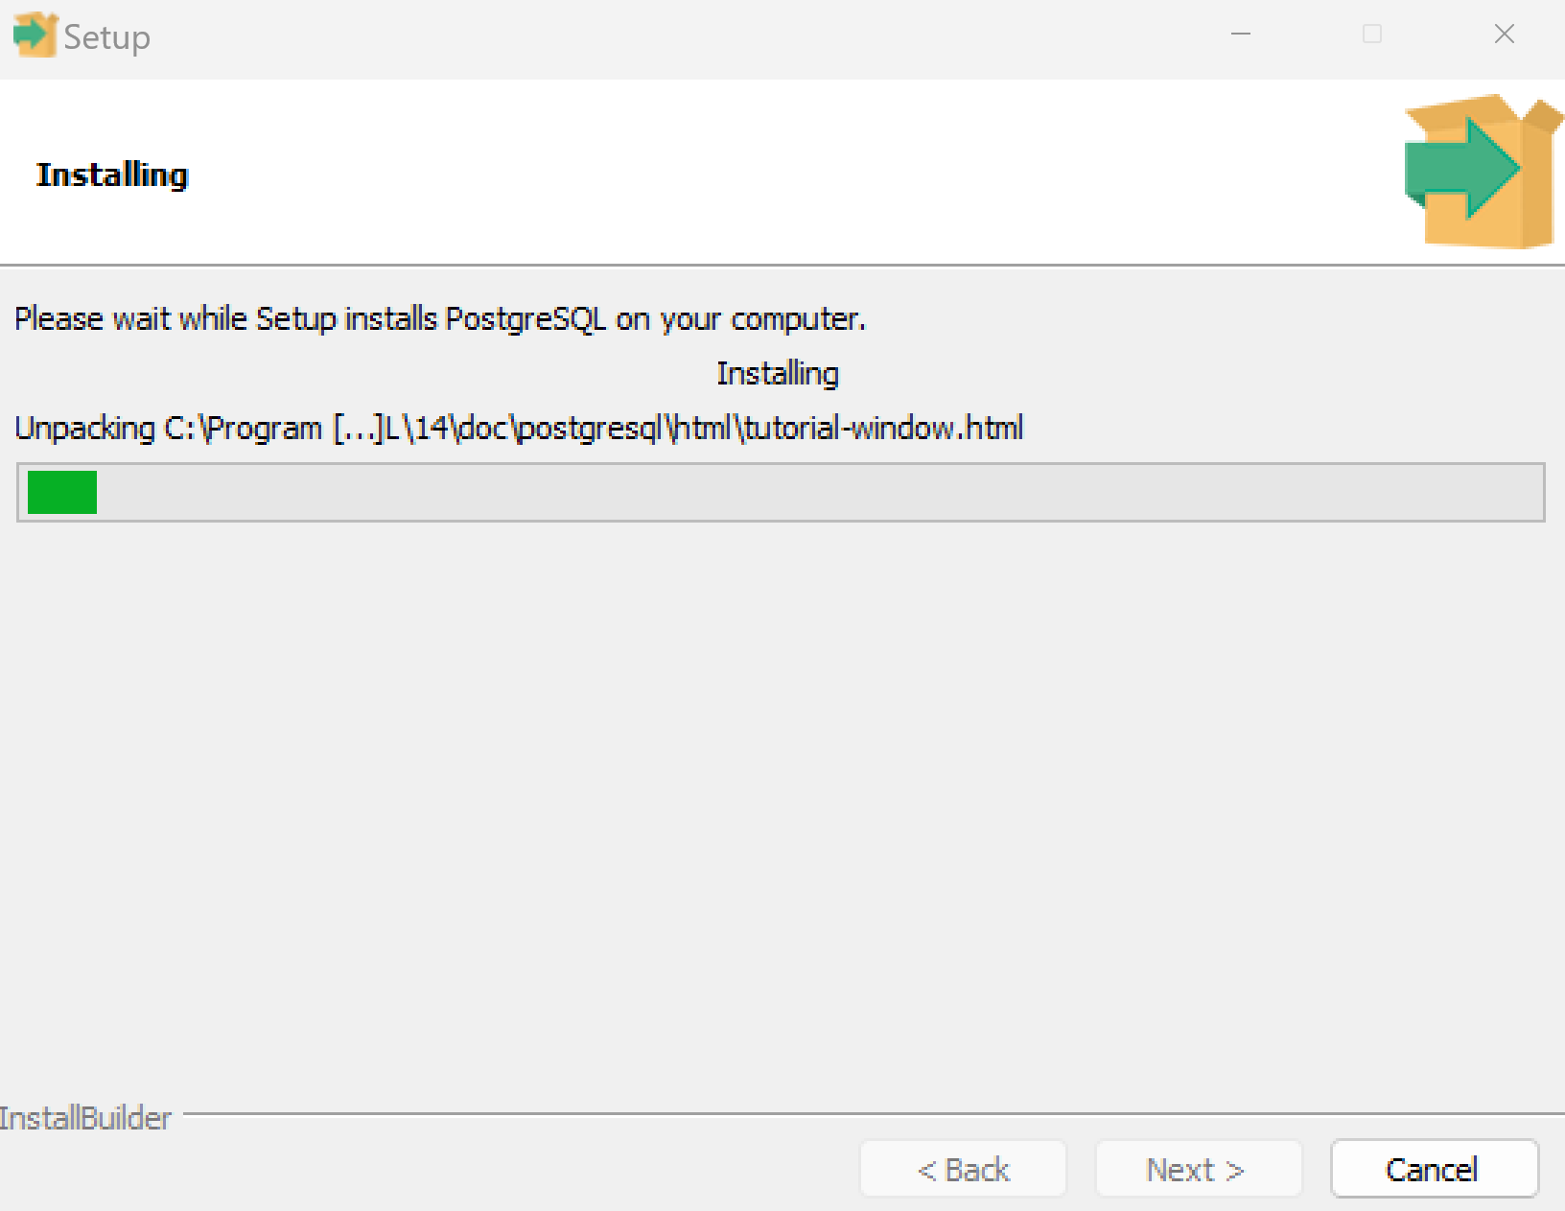

1. Once the program is installed, a confirmation window is shown (see next figure). Click on the “Finish” button to complete the installation.

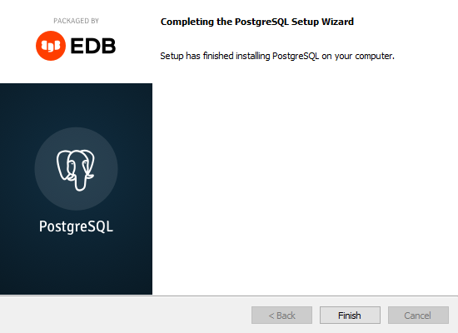

## SignAPROS Download

1. Enter the link <https://github.com/SaidS11/SignAPROS> in your preferred web browser, and click on the link from the README option to download the app.

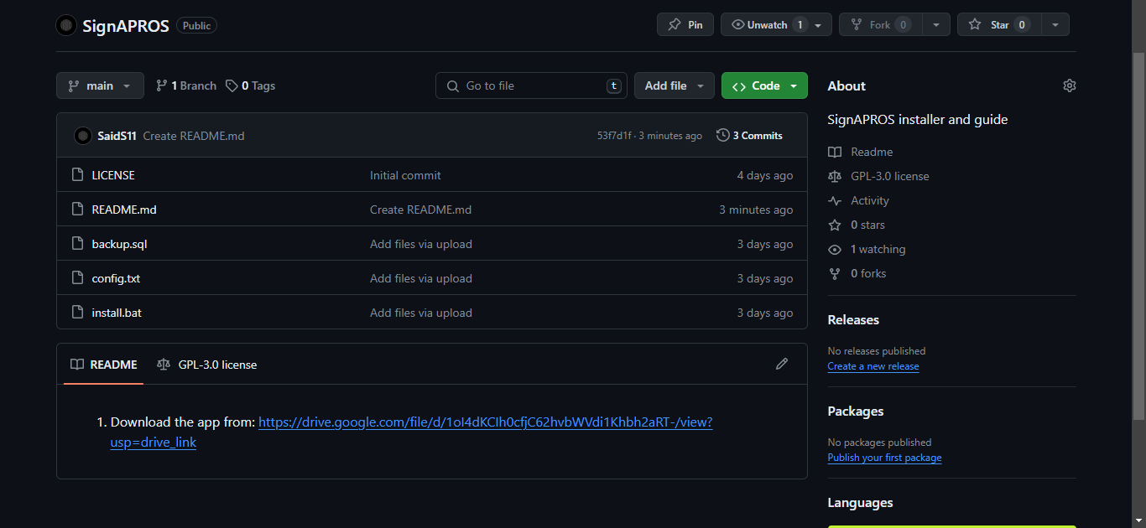

Press Download

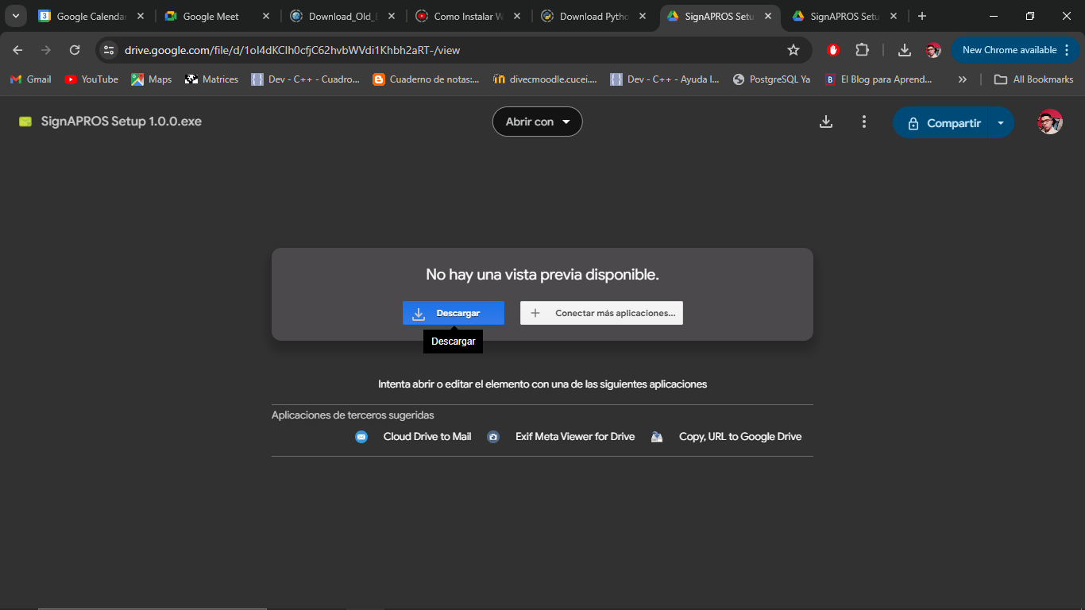

1. Then return to github and click on the “Code” button and then Download ZIP to get all the files you need.

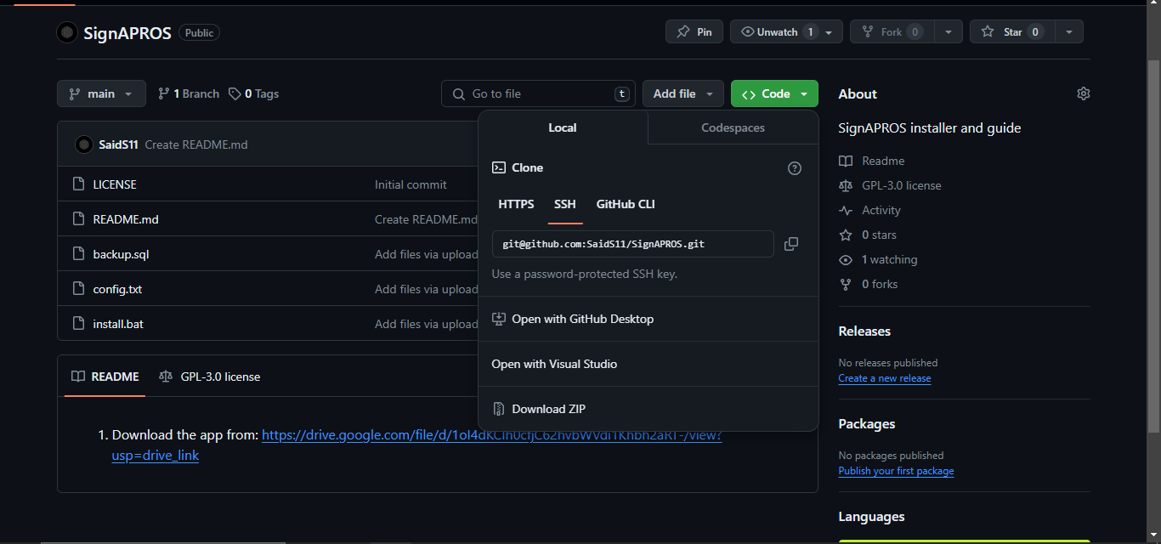

1. The download starts.

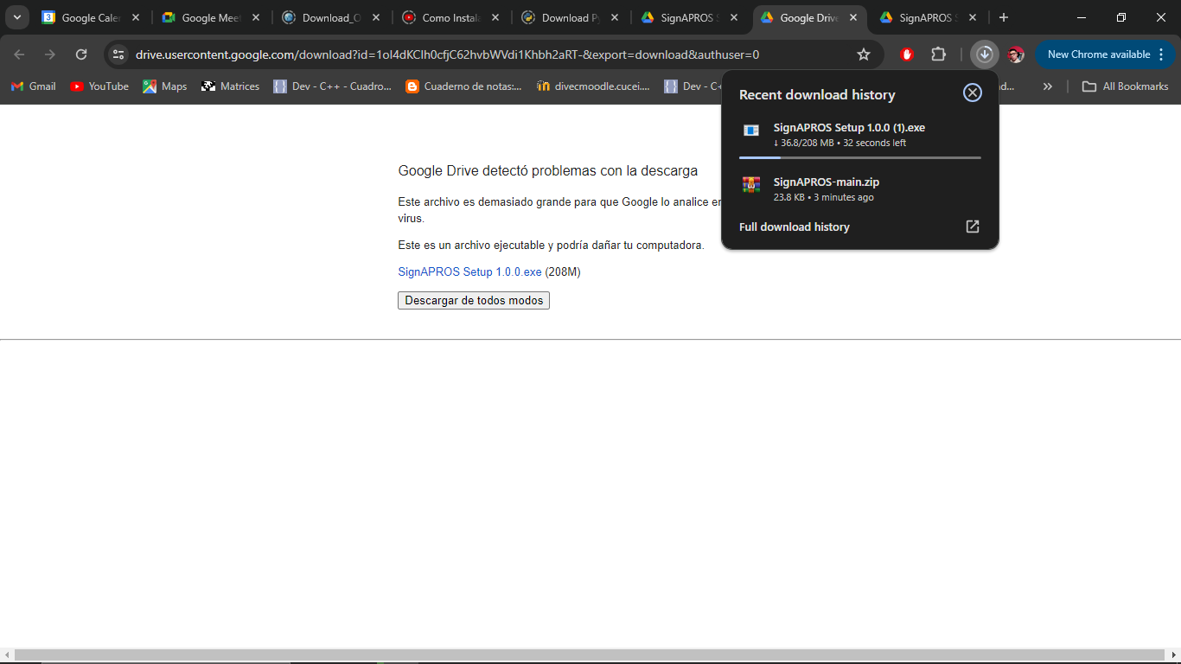

1. Go to the “Downloads” folder and extract the content of the zip file “SignAPROS-main.zip”. Go to the location where the content was extracted, you should be able to see the files shown below.

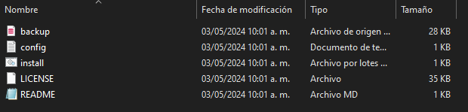

## Database creation

Before the user can access the SignAPROS program, a database must be created. Note that INTERNET CONNECTION is mandatory to follow the next steps.

1. To set the database parameters, open the “config.txt” file located in the folder of step B.4. The text file contains the parameters for the creation and connection of the database (see the following figure).

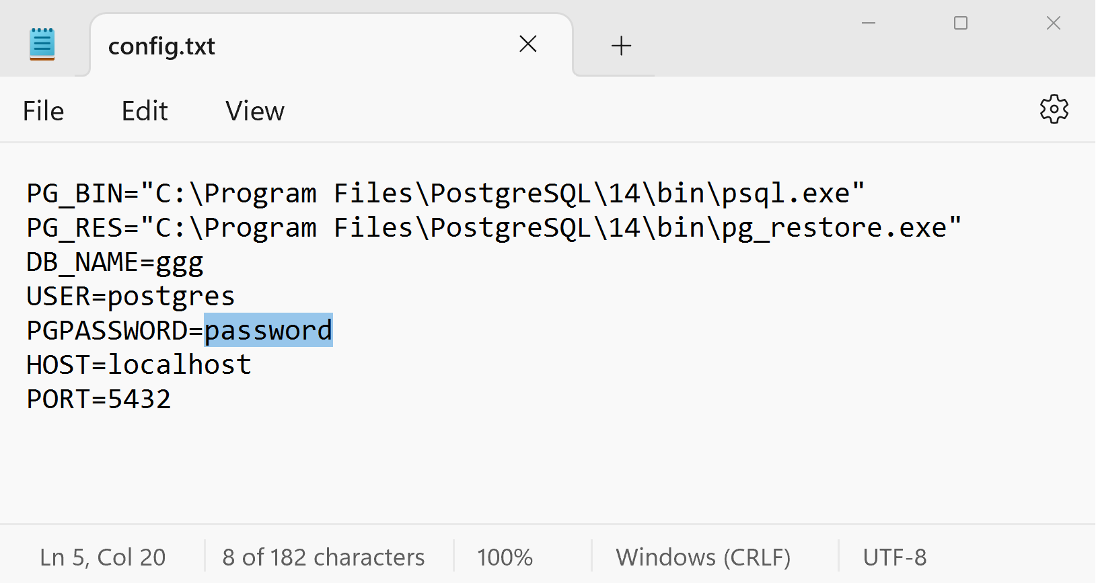

Note that, if you followed the PostgreSQL installation instructions by using the default paths, the only parameter that must be modified is the password (colored in blue in the figure) by changing the word “password” for the password set in the step C8, saving and closing the file. However, in the case of using different paths, the parameters to be set are defined below.

* 1. The first parameter is PG_BIN, here you must add the path where the psql.exe file is located, and the file path must be enclosed in quotes. If you choose the default option in step C.5, the path is “C:\Program Files\PostgreSQL\14\bin\psql.exe”
  2. The other parameter is PG_RES, here you must add the path where the pg_restore.exe file is located), the file path must be enclosed in quotes. If you choose the default option in step C.5, the path is "C:\Program Files\PostgreSQL\14\bin\pg_restore.exe"
  3. The next parameter is left to the user’s consideration, which is the name of the database (DB_NAME). We recommend to use “ggg”.
  4. The user for the database (USER) must be “postgres” and the password to access the database (PGPASSWORD) is the password set in the PostgreSQL installation (see step C.8).
  5. The default value of HOST is localhost (to create the database on the local machine) and the default port (PORT) is 5432. Parameters must be added in the order and format shown in the last figure.

1. Once the parameters have been set, execute the “install.bat” file located in the folder of step B.4 by double-clicking on it. A terminal window will display showing the progress of the installation.

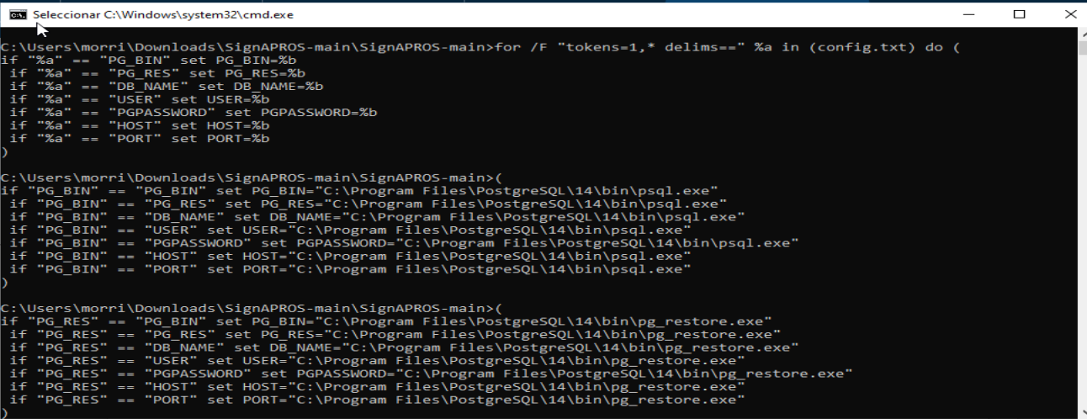



The Windows system may ask for your permission to run the file “install.bat” by showing a screen as follows, in that case, you should click on “More info” and then click on the “Run anyway” button.

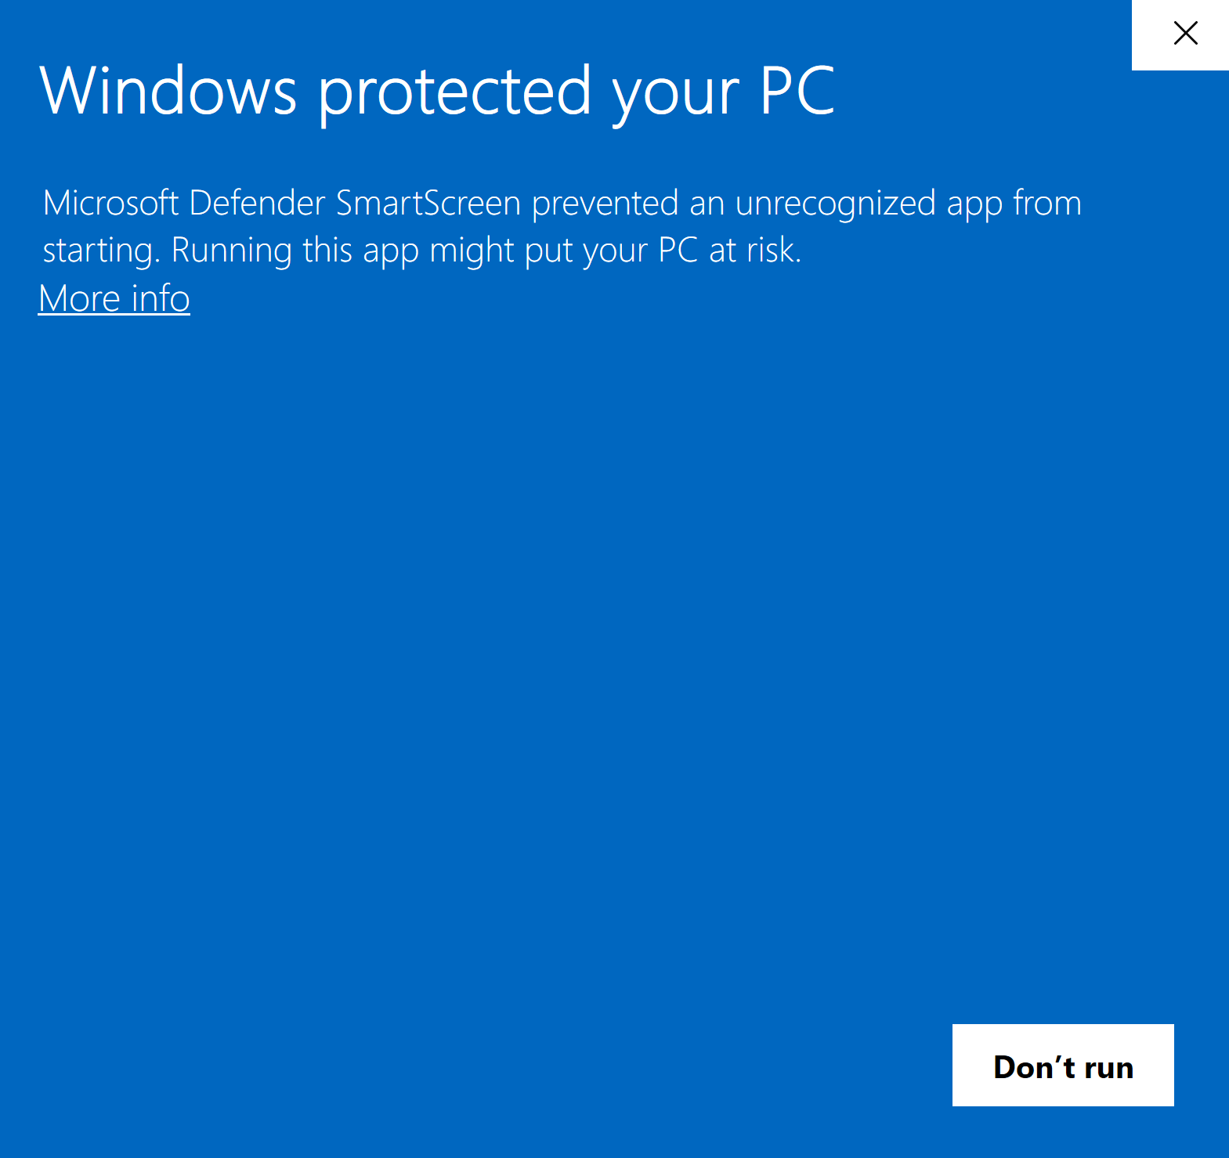

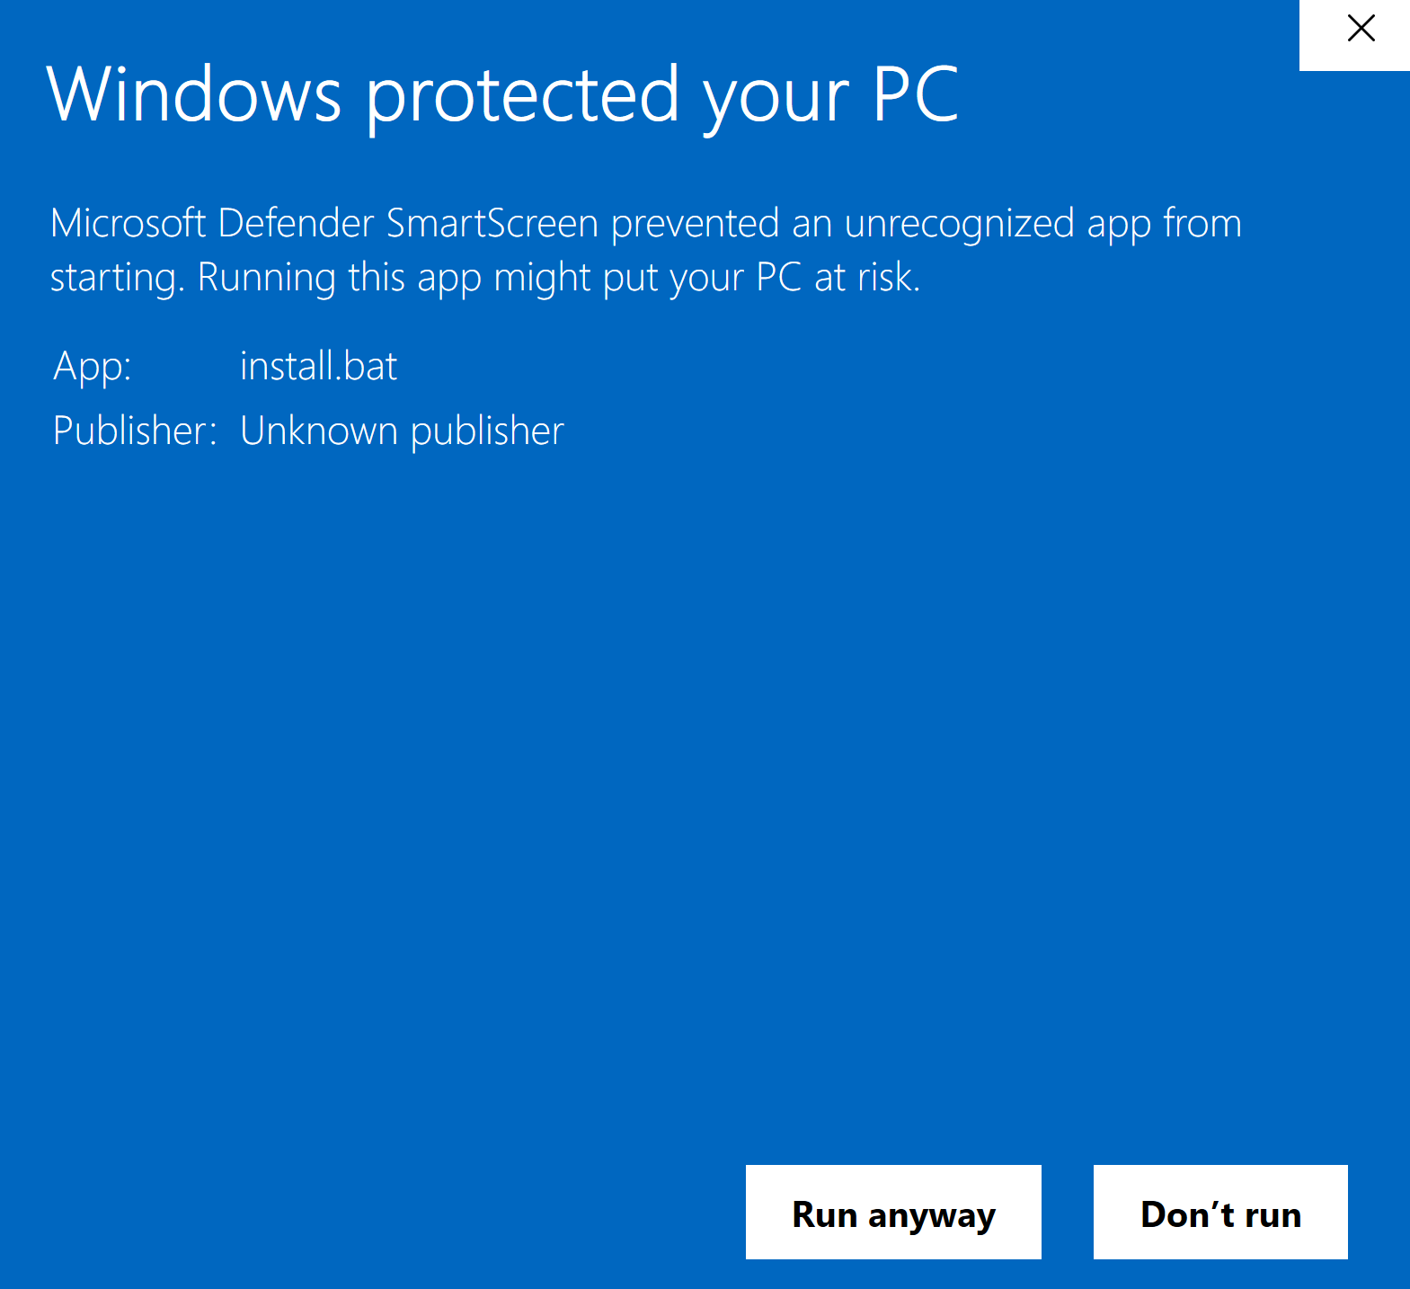

After finishing the above steps, the database is ready to connect with the GGG program.

## SignAPROS Installation

1. Go to the file created in step B.4 and run the “SignAPROS Setup 1.0.0” file by double-clicking on it. The Windows system may ask for your permission to run the file, in that case, you should click on “More info” and then click on the “Run anyway” button.



The Windows system may ask for your permission to run the file “SignAPROS Setup 1.0.0,exe” by showing a screen as follows, in that case, you should click on “More info” and then click on the “Run anyway” button.





1. Once the SignAPROS program is installed, the app will start.
2. Click the Set Up Database option

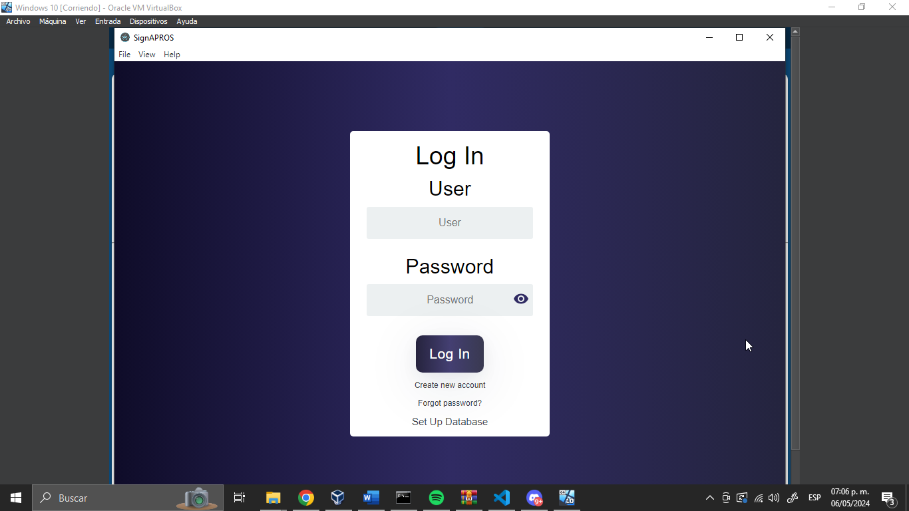

1. Fill all the necessary data to establish the connection with the database:

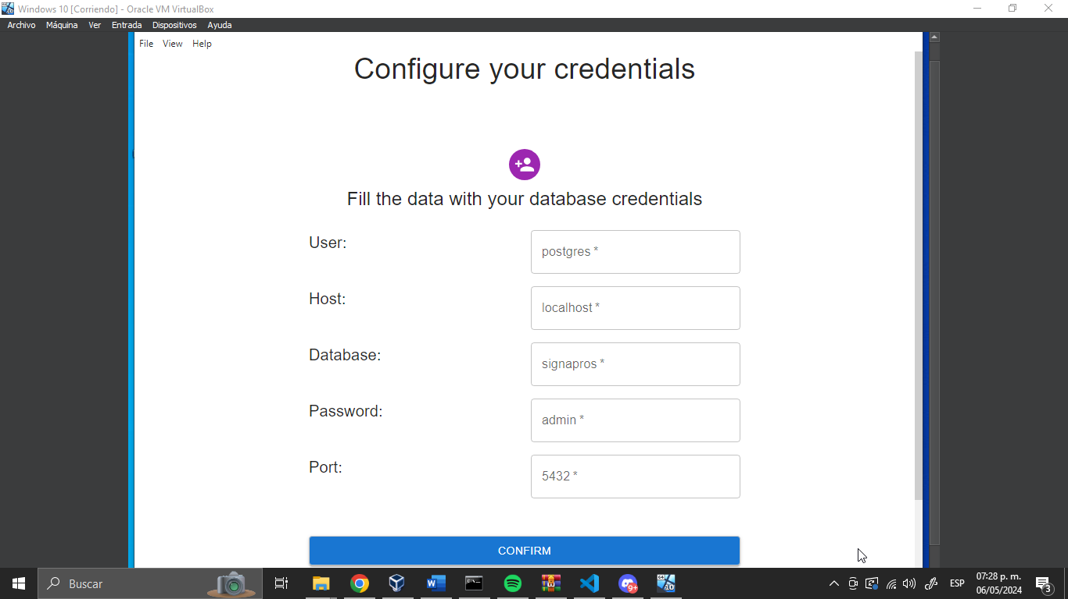

1. Now the application is installed in the folder:

C:\Users*your_user*\AppData\Local\Programs\signapros

1. To execute the SignAPROS program, open the “SignAPROS.exe” by double-clicking on it.

